

**MEMORANDUM OF UNDERSTANDING**

This is a document validating an agreement between **MR. OGABOR JOHN AND MR. OSHIOKE IGHADARO** for the collaborative of 20% interest over a sum of **FIVE MILLION NAIRA ONLY (N5,000,000) paid on the 15th of May, 2020.**

There is a binding agreement to pay the initial capital invested, alongside the interest, **SIX MILLION NAIRA ONLY (N6,000,000) on the 15th of June, 2020** by **MR. OGABOR JOHN TO MR. OSHIOKE IGHADARO.**

Attached with this document is an evidence of payment by **MR. OSHIOKE IGHADARO.**

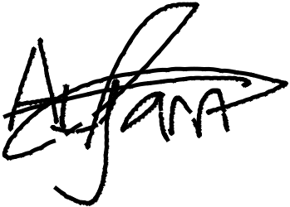

_________________________

_~~__~~_____~~___~~_~~_~~___________



**MR. OSHIOKE IGHADARO**

**MR. OGABOR JOHN**

***(CEO, JOHN INVESTMENTS)***